Nama : Ziyan Fadilla Saporette

NIM :18090058

Kelas : 5A

PRAKTIKUM 3

1. Source Code

Matakuliah.php-> application/controller

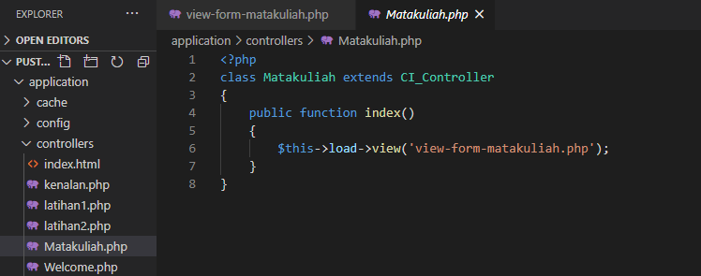

View-form-matakuliah.php->application/view

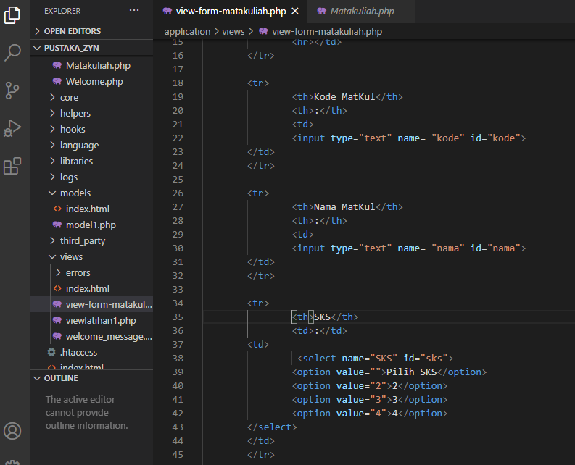

1. URL

<http://localhost:8090/pustaka_zyn/index.php/Matakuliah>

1. Capture Hasil

